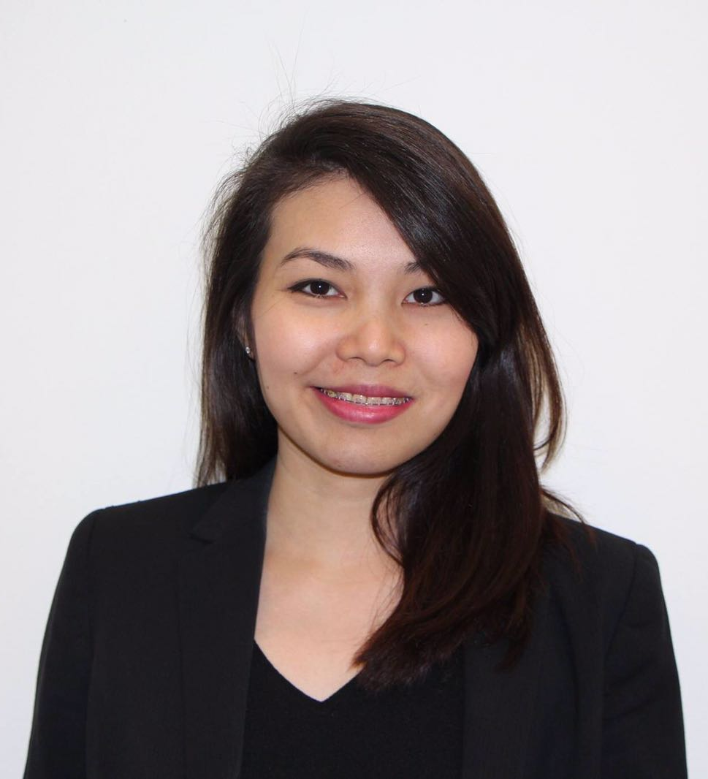
LOOK JIA LIN

PERSONAL INFORMATION
Address: Blk 76 Marine Drive, #09-05, Singapore 440076 – Telephone: 9683 5583
E-mail: laura_jialin@hotmail.com
Nationality: Malaysian (Singapore PR)

EXECUTIVE SUMMARY

Experienced accounting professional with more than 6 years of experience. Strong in liaising with various stakeholders to ensure compliance with standards and regulations. Adept at planning and organising resources to deadlines. Excellent interpersonal skills, especially focused on building relationships at all organizational levels.

KEY SKILLS

- Financial accounting  - Client management  - MAS regulatory reports  - Fund accounting | - Full sets of accounts  - Full spectrum of payroll function  - GST return  - Planning and resource allocation

WORK EXPERIENCE

Fund Accountant (Deputy Team Head), Partners Group (Singapore) | Nov 14 - Present
- Handle full sets of accounts for limited partnership/SICAR products
- Perform bank reconciliation, review and sign-off of financial transactions
- Prepare monthly, quarterly and yearly financial reporting (closing of accounts, accruals/prepayments, NAV calculation, hedge and stock distribution valuation, amortization of prepayments, cash and PIK interest of debt investments)
- Handling of requests from clients
- Calculation of fees (management, incentives and performance)
- Prepare quarterly financial statements which are issued to the investors
- Handle complex transfers and restructuring of investments
- Review legal documents (including but not limited to agreements, constituent documents and side letters) relating to assigned products
- Respond to internal and external client and auditor requests

Highlights
- Promoted from Analyst to Associate
- Appointed as Acting Team Head due to good performance
- Run a team of 6 Fund Accountants
- Conduct training across various jurisdiction (Switzerland, Singapore and Manila)

Associate (Business Outsourcing), Tricor, Singapore | Mar 12 – Nov 14
- Handled full sets of accounts; prepared monthly financial statements
- Administration of trust accounts
- Performed full spectrum of payroll function, including income tax return (IR8A, IR21 & A8A)
- Prepared and submitted GST returns to IRAS
- Converted financial statements into full XBRL
- Prepared MAS regulatory reports
- Ensured compliance with all statutory regulations
- Keyed and updated transactions into accounting system

Highlights
- Promoted from Assistant Associate to Associate
- Concurrently handled accounts for 20 companies across various industries - property, investment, recycling, retail & pharmaceutical
- Concurrently handled full spectrum of payroll function for 10 local and overseas companies (Dubai) with headcount of up to 500 staff across various industries – medical, retail, investment, recycling

Audit Associate, Low, Yap & Associates (Pioneer Associates), Singapore | Oct 11 – Mar 12
- Participated in audit teams, aiding in full spectrum of duties relating to liaising with client, determining timeline and ensure audit completed within resource constraints
- Analysed data and collated accurate management of financial reports
- Performed comprehensive analysis and tests to review efficiency in operations
- Conducted statutory audit

EDUCATION

- CPA Australia (In progress)
2016 – 2019

- Bachelor of Commerce (Accounting), University of South Australia (On-Campus) 2009 – 2011
GPA: 5.23/7.00 (75%)

- Diploma (TAFE Accounting), Inti International College Penang 2006 – 2008

LANGUAGE, SKILLS & INTERESTS

- Languages: Fluent in English, Mandarin, Bahasa Malaysia, Hokkien and Cantonese
- Technical Skills: Microsoft suite of applications (Excel, Words and PowerPoint), Bright Accounting system, EPE CORE, Abacus and E-Front
- Interests: Cooking and Travelling

Additional Details
⇩  
Notice Period: 3 months (negotiable)
Current Salary: SGD 73,200 p.a.
Expected Salary: SGD 6’000 p.m.

